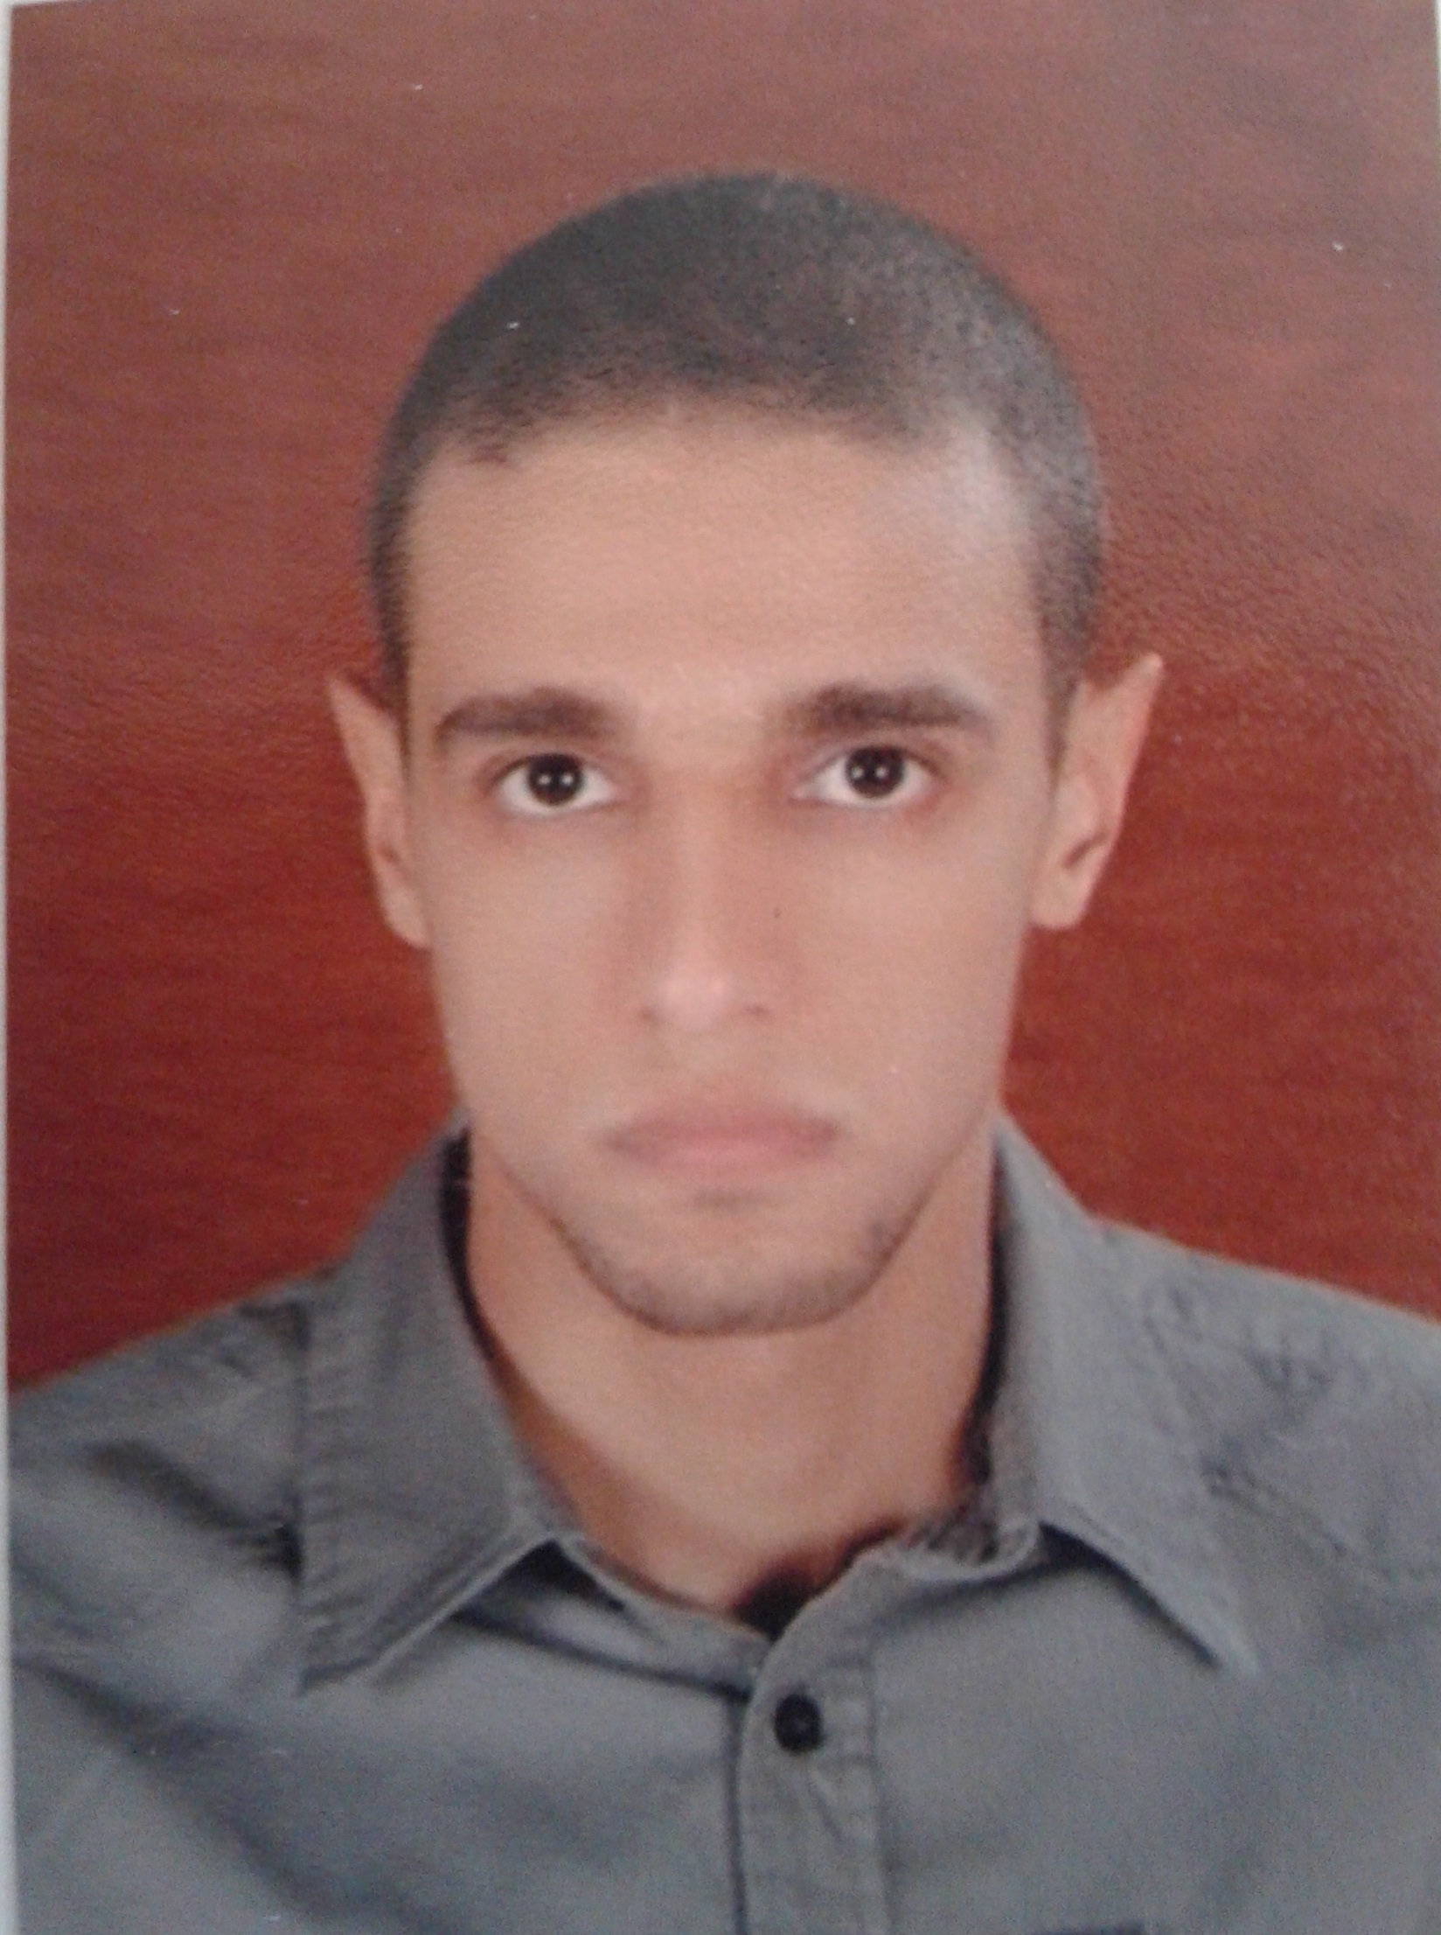
Khaled Saad Abdullah Abdelrahman

Apt 3, Building 2, Block B, District 5, 15 May city, Cario
Mobile: 01002573620 - 01282142081
E-Mail: elgendy1204@yahoo.com
Personal Information
- Date of Birth : 12/4/1989.
- Place of Birth : Cairo.
- Marital Status : Single.
- Military Status : Exempted.
- Nationality : Egyptian.
Programming Education
- Java
  - Desktop applications.
  - Introduction to networking.
  - Database integration with Java.
  - Fundamentals of Java servlets, JSP and JSTL.
- MySQL
  - Fundamentals of MySQL database.
- C++
  - C++ basics.
- Mobile development
  - cordova.
  - Familiar with ionic mobile framework .
- Web front end programming
  - HTML5.
  - CSS3 and CSS3 preprocessors i.e. LESS and SASS.
  - CSS3 preprocessors libraries. i.e. compass.
  - Bootstrap.
  - JavaScript, JQuery and other JavaScript libraries.
  - Familiar with any JavaScript Framwork: i.e. backbone, vue, angular.
- Version control and Workflow
  - Git.
  - Grunt and gulp task runners
  - Bower and node package managers tools.
Programming Experience
- Freelancer programmer (from 10-2014 to 11-2015)
  - Database program using Java + MySQL + git for SkyTech office.
  - Fawry operations program using Java for SkyTech office.
- Modern Arabic Foundation
- Front-end developer team leader of the contents builder’s.
- Incorporating SASS and git technologies into the work.
Chemistry Education
- Faculty of Science, Helwan University (July 2011):
  - B.Sc. in Special Chemistry.
  - Total Grade : good.
  - Project : Chemical Composition of Petroleum and its Petrochemicals.
  - Project degree : Excellent.

aDVANCED Chemistry eDUCATION
- Faculty of Science, Cairo University :
- Pre-master in Physical Chemistry. (2011-2012)
- Grade: Very good.
- Finishing M.Sc. (Quantitative structure activity relationship analysis of some chemical compounds using quantum calculations).
SCIENTIFIC PAPERS PUBLISHED
- Mohamed E. Elshakre, Hussein Moustafa, Huwaida M. E. Hassaneen, Khaled Saad Abdullah. (2015); Electronic spectra, and DFT calculations of some triazolo [1,5-a]pyrimidine derivatives, Int. J. of Adv. Res. 3 (5) 703-722 (ISSN 2320-5407).
OTHER EXPERIENCE
- SkyTech office (2-3 Years)
- Sales: Computer accessories (Software and Hardware) – mobile accessories – electrical accessories.
- Computer technician: Software and hardware computer Maintenance.
- Research and development (3 Years) - Related to the M.Sc.
- Researching for improving the biological activities of some chemical compounds.
- Quantum analysis of some compounds to get the geometry optimization, to characterize the compounds and to illustrate the solvent effect on them.
- Experimental and theoretical spectroscopic analysis of some triazolopyrimidine derivatives.
Chemistry training
- Cairo for Petroleum Refining, Cairo, Egypt. (Jul,2010 )
- Training in Analytical Laboratories. (2 weeks).
- Training on Industrial Security. (2 weeks).
- Water Station, Cairo, Egypt. (August,2010 )
- Training in Analytical Laboratories. (Month).
- The Arab Contractors, Cairo, Egypt. (June,2014 )
- Soil mechanics. (Month).
courses
- TOEFL (Cairo University)
- Score: 573 (95.5%)
skills
- Personal Skills:
- Ability to learn quickly and implement new skills.
- Ability to be a team Member and be an effective part.
- Fast in Self-learning.
- Computer Skills:
- Windows Operating System.
- Windows, Word, Excel, Power Point & Internet.
- Programming using Java and MYSQL.
- Introduction to C++.
- High knowledge of HTML, CSS and Javascript languages.
Language
- Native language: Arabic.
- English:
- Reading : good
- Writing : good
- Speaking : good

